**EXPERIMENT NO 3:**

**Use matplot library to plot graph for data visualization using Python**

We can create a line plot in matplotlib using the plt. plot() method where the first argument is the x variable and the second argument is the y variable in our line plot.

**What is Matplotlib?**

Matplotlib is a popular Python library for displaying data and creating static, animated, and interactive plots. This program lets you draw appealing and informative graphics like line plots, scatter plots, histograms, and bar charts.

**What is Data Visualization?**

Data visualization refers to the integration of data and visual elements like images, charts, diagrams, and so on to communicate messages to different stakeholders.

These stakeholders can be users, team members, managers, or top executive members of an organization.

#Imports packages

import pandas as pd

import matplotlib.pyplot as plt

import numpy as np

import matplotlib.dates as mdates

From matplotlib.ticker import MaxNLocator

**Create a Bar Chart**

plt.figure(figsize= (8, 6))

industry_val=df_layoffs.groupby('company')['total_laid_off'].sum().sort_values(ascending = False).head(10) industry_val.plot(label="", kind='bar')

plt.show()

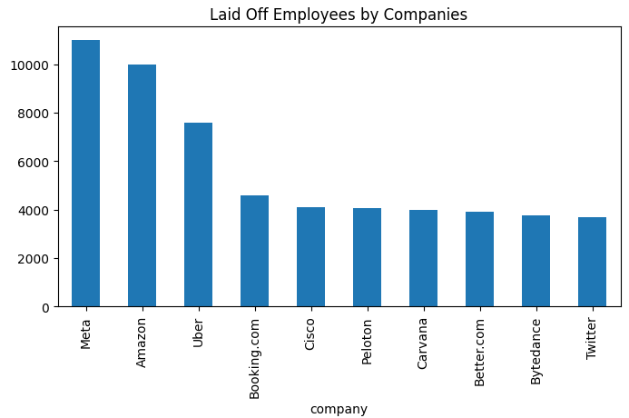

**Create a Pie Chart**

# Group the data by industry and sum the total laid off employees

industry_val=df_layoffs.groupby('industry')['total_laid_off'].sum().sort_values(ascending=False).head()

# create the pie chart and display the labels and values inside the pie

plt.figure(figsize=(8, 6))

plt.pie(industry_val, labels=industry_val.index, autopct='%1.1f%%')

plt.title('Laid Off Employees by Industry')

plt.show()

